- Smart Doorbell (Surveillance & Monitoring)
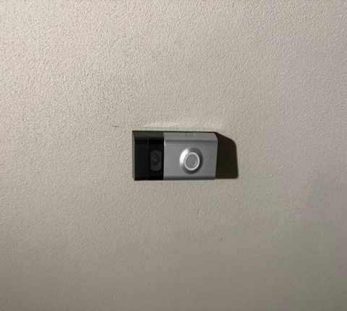

Explanation:
A smart doorbell includes a camera and motion detection system. It allows homeowners to monitor visitors in real-time through a mobile device. This enhances security by providing surveillance and recording suspicious activity.
Security Concept: Surveillance + Remote Monitoring

- Door Lock (Physical Access Control)
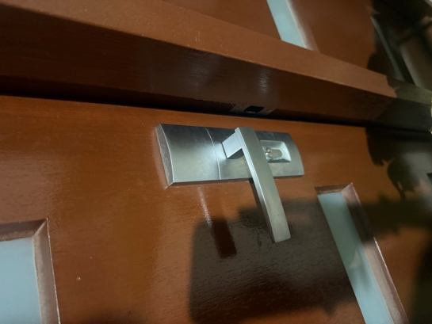

Explanation:
The door lock restricts unauthorized entry and ensures only individuals with the correct key can access the house. It is one of the most basic and essential physical security measures.
Security Concept: Access Control

- Alarm System Panel (Intrusion Detection)
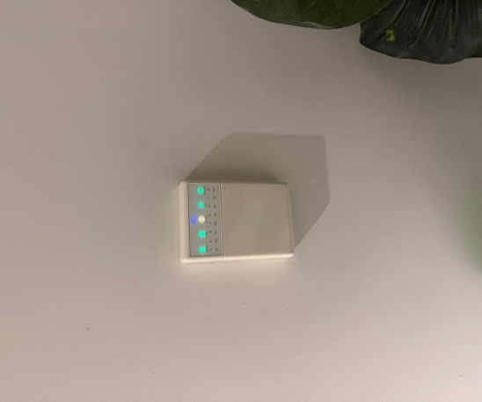

Explanation:
The alarm panel is part of a home security system that detects unauthorized access. It alerts the homeowner or security service when suspicious activity is detected.
Security Concept: Intrusion Detection + Alert System

- Wi-Fi Router (Network Security)

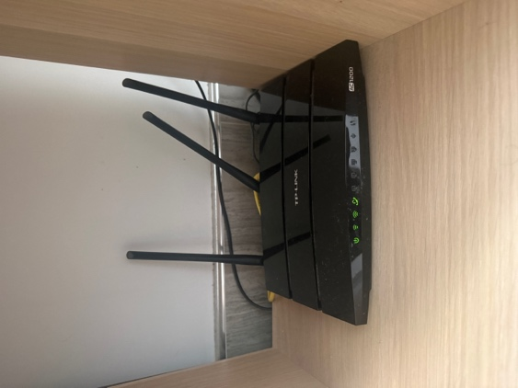

Explanation:
The router controls internet access and uses security protocols such as passwords and encryption (WPA2/WPA3). It prevents unauthorized users from accessing the home network.
Security Concept: Network Security + Encryption

Summary Table:-

Device | Location | Security Concept | Purpose
Smart Doorbell | Entrance | Surveillance | Monitor visitors and record activity
Door Lock | Door | Access Control | Prevent unauthorized entry
Alarm Panel | Inside wall | Intrusion Detection | Detect and alert security threats
Wi-Fi Router | Living area | Network Security | Protect internet access

